EJERCICIO:

Con el comprobador de tipos de la p.25 analizar el siguiente programa fuente de entrada:

a : ^ integer ;

b : array [ 5 ] of ^ char ;

c : ^ ^ char ;

1. **ANALISIS LEXICO:**

id1 : ^ integer ;

id2 : array [ num ] of ^ char ;

id4 : ^ ^ char ;

**TABLA DE SIMBOLOS**

|  |  |  |  |
| --- | --- | --- | --- |
| **Entrada** | **Lexema** | **Complex** | **Tipo** |
| 1 | a | id |  |
| 2 | b | id |  |
| 3 | 5 | num |  |
| 4 | c | id |  |

1. **ANALISIS SINTACTICO - SEMANTICO:**

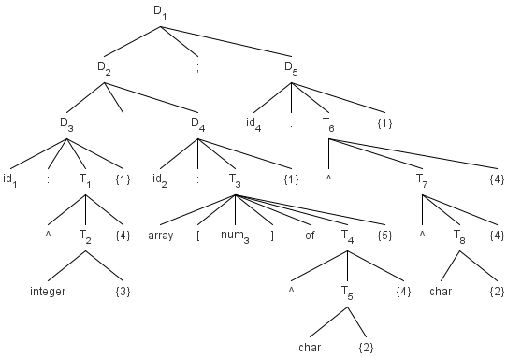

**RECORRIDO DEL ARBOL (COMPROBADOR DE TIPOS)**

**TABLA DE SIMBOLOS**

|  |  |  |  |
| --- | --- | --- | --- |
| **Entrada** | **Lexema** | **Complex** | **Tipo** |
| 1 | a | id | pointer(integer) |
| 2 | b | id | array (1..5, pointer(char)) |
| 3 | 5 | num | integer |
| 4 | c | id | pointer(pointer(char)) |

|  |  |
| --- | --- |
| **ATRIBUTOS** | |
| **Simbolo** | **Tipo** |
| D1 |  |
| D2 |  |
| D3 |  |
| D4 |  |
| T1 | pointer(integer) |
| T2 | integer |
| T3 | array (1..5, pointer(char)) |
| T4 | pointer(char) |
| T5 | char |
| D5 |  |
| T6 | pointer(pointer(char)) |
| T7 | pointer(char) |
| T8 | char |